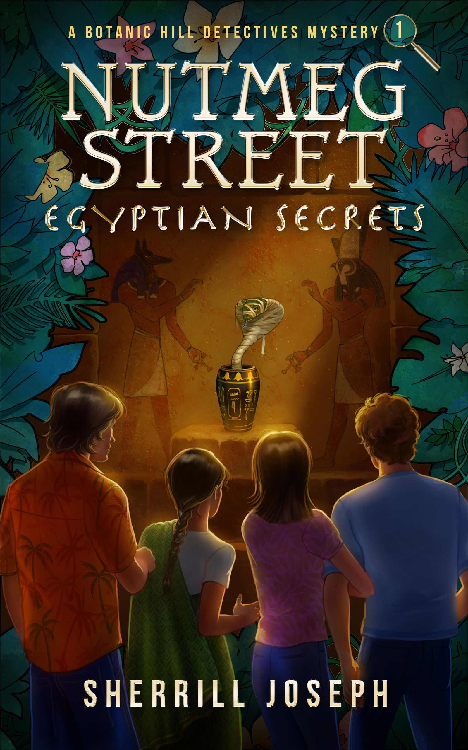

Instructional Tools and Book Study Guide
for
Nutmeg Street: Egyptian Secrets,
Book 1 of the Botanic Hill Detectives Mysteries Series

Prepared by
Sherrill Joseph
July 2020

K-12 Literacy Teacher, Retired
Advocate for Teachers, Tutors, Librarians, Kids, and Their Families
Author of the Botanic Hill Detectives Mysteries Series

For All Who Teach and Love Kids
Table of Contents

Select Reading Pedagogy 3
Introduction 4
The Common Core State Standards for English Language Arts 5
The Gradual Release of Responsibility Model for Instruction & Learning—To, With, and By 6
Reading Comprehension Strategies to Enhance Understanding 7
The Ten Dimensions of Reader Response for Engaged, Reflective Reading 8
Bloom’s Taxonomy to Help Empower Students’ Critical Thinking and Comprehension 9

Book Study Guide 13
#1 Nutmeg Street: Egyptian Secrets 14
Part I: Chapters 1-4 and Front Matter 14
Part II: Chapters 5-8 18
Part III: Chapters 9-12 21
Part IV: Chapters 13-16 24
Part V: Chapters 17-20 and Back Matter 27
Teacher’s Notes 30

Select Reading Pedagogy

The Reading Pedagogy section is intended as a review mainly for teachers,
but paraprofessionals and families may find the following pages
especially informative for helping children become proficient readers:
Pages 4, 7, and 9-12

Select Reading Pedagogy

Introduction

Here is my definition of reading: Reading is constructing meaning from text. It should be fun.

Notice my definition didn’t say that reading is decoding words. Of course, learning phonics, sight words, and decoding unfamiliar ones are important first steps that take courage, skill, and hard work for kids. And reading fluently (with accuracy, expression, and ease) is critical to comprehension. Please note that skill-and-drill worksheets can have their place, but overusing them will kill a child’s enthusiasm for reading and books.

If you really want to help kids learn and love to read, you have to teach them how to comprehend and expand upon the ideas on the page. So, instead of starting from a deficit model, what a child cannot do, start from a surplus one; that is, you have to show kids what good readers do.

For instructors needing help in this important work or to refresh your memory, please continue on in this section for reading comprehension tools and strategies that work. They correlate well to the Common Core State Standards, discussed on page 5. I have tried to integrate all discussed tools and comprehension strategies into the activities in my Book Study Guides. I’m sure you can add more!

An effective venue for teaching kids at or near the same reading level so they can share and care about what they’re reading is in small-group instruction and discussion called Guided Reading, aka Literature Circles or Book Clubs. Since kids are being guided by an instructor, they can read a text that is one level above their comfortable (independent) reading level. See page 6 for more information on Book Clubs.

The Book Study Guides in this document are designed for book clubs of two to seven participants (including the instructor), who are reading the same text together. The guides can also be used in other Readers’ Workshop arenas, such as Read Aloud, Shared Reading, and Independent Reading. But more about those on page 6.
The Common Core State Standards for English Language Arts (ELA)

The Common Core State Standards for ELA are guidelines used (mainly by school districts) “to identify clear reading goals for what students must achieve and demonstrate in each grade level in order to be college, career, and community ready in literacy by the end of high school.” To date, forty-one states, four US territories, the District of Columbia, and the Department of Defense Education Activity have adopted the Common Core State Standards. Has your state? Check at http://www.corestandards.org/standards-in-your-state/
More specifically, these standards ask students to read stories and literature (fiction), as well as more complex texts (nonfiction) that provide facts and background knowledge in areas such as science and social studies. Students must also learn to write, speak, listen, and use language effectively in a variety of content areas. They will be challenged and asked questions that push them to refer back to what they’ve read. This stresses critical-thinking, problem-solving, and analytical skills that are required for success in college, career, and life. This also makes the case for students learning effective reading comprehension strategies early in school so that they are better positioned not only to achieve the standards, but also to develop a lifelong love of reading and appreciation for the art of writing. These in part inform the goals of my Book Study Guides.
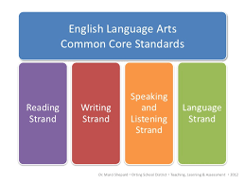
The College and Career Readiness (CCR) Anchor Standards form the backbone of the Common Core State ELA/literacy standards by articulating core knowledge and skills, while grade-specific standards provide additional specificity.
You don’t have to be a classroom teacher to familiarize yourself with the Common Core Standards. They are available to all.
If you are new to the Standards, here is a walk-though, get-acquainted exercise for you to try. Go to http://www.corestandards.org/ELA-Literacy/CCRA/SL/ to read the specific CCR anchor and core state standards for your grade level and subject area. These can be found on the right-hand side of the page in the orange and gold box. Next, try this example: In that box, click on Reading: Literature—Grade 5. Then, on the left, click on “Standards in This Strand”—CCSS.ELA—Literacy.RL 5.1 (Translation: Common Core State Standard for English Language Arts, Literacy, Reading Literature, Standard Grade 5, First Goal)
CCSS.ELA-LITERACY.RL.5.1 (RL, “Reading Literature” refers to fiction. Nonfiction has its own standards.)
“Quote accurately from a text when explaining what the text says explicitly and when drawing inferences from the text.”
Important: Some students will need extra help in knowing and practicing the high-level comprehension strategy of inferring to achieve just this standard! Please read on for how to help.
The Gradual Release of Responsibility Model for Instruction and Learning—To, With, and By
Paraphrasing Margaret E. Mooney in her landmark book, Reading To, With, and By Children, what happens during reading time at school affects children’s views of themselves and their world. She praises instructors “who have the privilege of helping children develop their view of reading.” Thanks, Ms. Mooney, but how do we do that?
Mooney says that adults can help kids learn to read by crafting instruction such that there are times daily for students to
- listen to others read to them without necessarily seeing the text
- see the text while listening to others read to them
- have the text in hand and read and discuss it with others who are at or near their own reading level
- have the text in hand and read by themselves or to others

The above four approaches, often called “Readers’ Workshop,” are the To, With, and By model, also known as the Gradual Release of Responsibility model, in action, as follows. Please visualize this:

What Students are Doing | Gradual Release of Responsibility Effective Teaching & Learning Model | The Corresponding Readers’ Workshop Component
- Listening to others read to them without seeing the text (maybe just the illustrations) | Being Read “To” = Greatest Support since the kids are listening only while being read to by the instructor. | Read Aloud (Instructor reads aloud to students, who might be at their seats or on the rug. This widens their horizons, “world” experiences, and appreciation for books in a safe way.)
- Seeing the text while listening to others read to them | “Reading “With” the Instructor =  Supportive since the adult is reading, but kids have their eyes on the text now, and sometimes, join in the reading when they feel comfortable to do so. | Shared Reading (Text could be on the screen or copies in kids’ hands. Kids might be at their seats or on the rug. It replicates the cozy “bedtime story” approach for reading enjoyment.)
- With all having the same text in hand, reading and discussing it with an adult and others who are at or near the small group’s reading level | “Reading “With” the Instructor =  Supportive but less than #2 since now, the kids have the text in hand and are expected to read and discuss it in a small group. The instructor remains the guide, but students who are ready can pose questions and steer the discussion in new directions. | Guided Reading (Each student in the Book Club group has the same text in hand. Students are with the adult at a table or rug. The instructor guides the discussion for comprehension and must constantly determine how much support to give or release to the group and each individual member.)
- With a text in hand, reading alone or to others | Reading “By” themselves on “autopilot” = No Support since the instructor isn’t sitting with or guiding the student, who is reading alone, or buddy-reading, with ease. | Independent Reading (Students have text and read on their own without help. They might be at their seats or in a reading corner.)

If you think about the teaching and learning model above, it’s the way we master learning, and not just learning to read. It can be applied to learning how to write, speak, ride a tricycle or bicycle, drive a car, or fly a plane—just about anything.
Why? Because the effective instructor knows when and how much to support and when and how much to let go.
Reading Comprehension Strategies to Enhance Understanding
So, what do Good (Proficient) Readers do? Ultimately, they
- bring their background (prior) knowledge to what they read (self-to-text)
- construct meaning from what they read so they understand the text
- think while they read (mind journeys)
- make decisions about what is most important in the text
- have conversations and ask questions about what they read
- take what they learn from reading back into their lives (text-to-self/world)
- connect to similar books (text-to-text)
- like/love to read
- develop a lifelong love of reading and books
This is what we want for all kids . . . and as early as possible. How do we get them there?
Instructors can spend time modeling for readers how to become Good Readers by “articulating and focusing instruction on the mental processes that underlie reading. . . . They do this by sharing their own thought processes as they read” (Keene and Zimmermann, Mosaic of Thought). If some students don’t have enough background knowledge to understand the text, instructors should help them build that, too.
Through the To-With-By model (page 6), instructors can demonstrate these mental processes of reading by using a variety of texts, then gradually release the task to kids. The goal is to make kids more conscious of their own thinking processes as readers—Good Readers—so they can take the strategies to the independent level.

The Seven Key Reading Comprehension Strategies to Enhance Understanding*
Making Connections-- self-to-text; text-to-self/world; text-to-text: (“It reminds me of . . .”)
Questioning— to develop curiosity and propel the reader forward in the text: (“Why did he . . . ?)
Visualizing— making a movie in your mind to personalize reading, keep you engaged, and bring reading to life

Inferring-- reading between the lines for clues to understand feelings, moods, actions, and the thoughts of the
characters. Can be open-ended and left unresolved by the end of the text: (“She seems sad because . . .”)

Predicting— stating a possible logical (emphasis on the word logical) outcome, event, or action that is confirmed or
contradicted by the end of the story from evidence: (“I think they will . . . because . . .” )

Determining Importance-- sifting and sorting information to make sense of the reading (mainly in nonfiction);
making decisions about what to remember and what to disregard. Involves overviewing, watching for features that signal importance, e.g., italicized words, headings, captions, titles, bulleted lists, cue words and phrases, boldface text, graphics, illustrations, photographs, text organizers, etc.

Synthesizing— combining a number of parts to create a new whole, e.g., retelling or summarizing a story: include the
most important parts only; tell them briefly in a way that makes sense; try not to tell too much

*Source: Harvey and Goudvis, Strategies That Work: Teaching Comprehension to Enhance Understanding

The Ten Dimensions of Reader Response for Engaged, Reflective Reading

Jeffrey Wilhelm, in his text You Gotta BE the Book, shares a conversation between two student reading partners:
John: “I can’t believe you do all that stuff when you read! . . . I’m not doing . . . nothing compared to you.”
Ron: “I can’t believe you don’t, man . . . If you don’t, you’re not reading . . .It’s gotta be like watching a movie or playing a video game . . . you’ve got to like . . . be there!”

Critical Note: Watch for the overlap among Wilhelm, Keene and Zimmermann (page 7), Harvey and Goudvis (page 7), Bloom (page 9), and the Common Core Standards (page 5). I have used red text below to show some of the connections. This overlap strengthens the case for incorporating deep comprehension strategies in teaching.

Here is Wilhelm’s rich variety of ten instructional strategies, or dimensions, that help kids engage as readers so reading is fun, satisfying, meaning-making, and engaging for them. This can and should inform teaching:

- Entering the Story World—Students prepare to read and start thinking about what the reading will be like. They activate prior knowledge that could help them read.
- Showing Interest in the Story—Readers comprehend the literal meaning of the plot and become interested in it as they read. They make predictions and form expectations about the story action.
- Relating to Characters—Readers seek out the characters and take up relationships with them. The reader often becomes a presence in the story and makes judgments about the characters.
- Seeing the Story World—Readers notice clues for creating mental images and visualize characters, settings, and situations.
- Elaborating on the Story World—Readers build up clues as they read to create meaning by playing “detective” to flesh out clues and fill in story gaps, often creating meaning that goes well beyond the text.
- Connecting Literature to Life—Readers make explicit connections between personal and character experiences, often looking for ideas that can inform how they could solve problems in their own lives.
- Considering Significance—Readers ask how the text works to create meaning and considered the significance of various events and behavior and how this contributes to the story’s meaning.
- Recognizing Literary Conventions—Readers notice that the author sets them up for responses to particular kinds of conventional moves and use previous experiences from their reading or discussions to figure out how to do so.
- Recognizing Reading as Transaction--Readers recognize an author’s style in the story. The author might be embraced or rejected as a person to converse and agree with. The readers know they are creating meaning with the author and the text.
- Evaluating an Author and the Self as Reader—Readers consider the author’s agenda and their own. They size up the author’s effectiveness as a writer. They consider their own reading processes and how these relate to their personal identities.

Wilhelm fears that some instructors “typically neglect these important readerly dimensions when planning classroom activities, asking questions, and discussing reading” (Wilhelm, page 47). These dimensions are rich and foundational for effective teaching toward reading proficiency.
Bloom’s Taxonomy to Help Empower Students’ Critical Thinking and Comprehension
What is a “taxonomy”? According to edgalaxy.com, “A taxonomy is an orderly classification of items according to a systematic relationship (low to high, small to big, simple to complex).”
Bloom's taxonomy, a framework for categorizing educational objectives, or classifications, for mastery learning, was created in 1956 by American educational psychologist Benjamin Bloom, et.al. The taxonomy has helped teachers plan lessons and design instruction for decades now. “While other theories and systems have come and gone, Bloom's taxonomy appears to have become the most commonly used standard in many educational settings” (edgalaxy.com).
Bloom’s taxonomy originally consisted of six major hierarchical skills, or categories of thinking for question-asking: Knowledge, Comprehension, Application, Analysis, Synthesis, and Evaluation. In the 1990s, the taxonomy was updated to make it more relevant for 21st century students and teachers by transforming the nouns to verbs, e.g., “Knowledge” became “Remember,” “Comprehension” became “Understand,” etc.
See the pyramid below for the six updated categories, their descriptions, and key command words. The order of the top two, “Synthesis/Create” and “Evaluation/Evaluate,” was flipped, with “Create,” now at the top. The skills are shown in an upward-moving continuum from simple to complex and concrete to abstract. In summary, “Remember” is the simplest, most concrete skill; “Create” is the most complex, abstract skill.
Note: To the right of each skill in the Taxonomy Pyramid below is its explanation and some key question words or commands that may be used to formulate questions that can deepen students’ critical thinking skills.
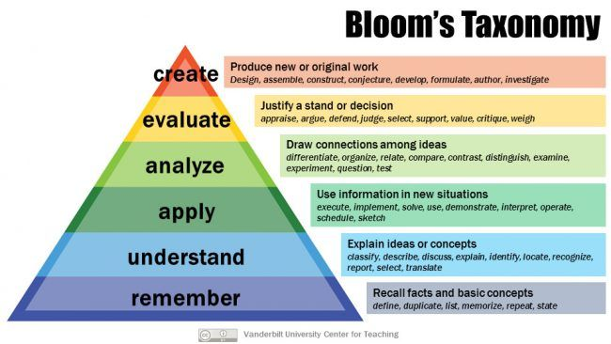
Bloom’s Taxonomy to Help Empower Students’ Critical Thinking and Comprehension (continued)
Important: In the table below, the taxonomy descends from the lowest to the highest thinking and comprehending levels to show the skills progression. Thoughtco.com says, “Sprinkle a variety of question types throughout every lesson, regardless of the topic or the grade level. Bloom’s Taxonomy is NOT grade specific. The six levels of questions are appropriate for ALL grade levels.”
Applying Bloom’s Taxonomy: Formulating Questions and Commands to Empower Reading & Thinking Skills

Taxonomy Skills  (lowest to highest) | Important Information About This Skill Level | Key Words Often Used or Implied in Questions | Sample Questions or Commands
- Remember  (Knowledge) | Lowest level of questions. Requires students to recall factual, literal information. Usually requires students to identify information in basically the same form it was presented. Overused. | know, who, define, what,where, when, recite, state, duplicate, label, select, locate, list, name, describe, memorize | “What did the main character do?”  “Who wrote the story?”  “Name the characters in our book.”  “List the events that occurred.”  “Where does the story take place?”
- Understand  (Comprehension) | Comprehension is the way in which ideas are organized into categories. These questions ask students to take several bits of information and put them into a single category or grouping. These questions go beyond simple recall and require students to combine data. | know, who, define, what, name, where, list, when, match, restate, explain, extend, summarize, give examples, predict, express, paraphrase, rewrite, classify, discuss, interpret, compare | “What is this story about?”  “What is the main idea/theme (lesson or message) of this story?”  “Match like characters. Explain.”  “Discuss the character’s actions.”  “Summarize the chapters.”  “Compare two characters.”  “Restate your favorite part.”
- Apply  (Application) | Requires students to take information they already know and apply it to a new situation. In other words, they must use their knowledge to determine a correct response. | apply, manipulate, put to use, employ, dramatize, demonstrate, interpret, choose, organize, draw, prepare, generalize, solve, produce, paint, sketch, show, connect | “What is another story you can recall with a similar theme/character?”  “Illustrate a time when you had a similar experience as our hero.”  “If you had the same problem as our character, how would you solve it and why?”
- Analyze  (Analysis) | Requires students to break down something into its component parts. To analyze requires students to identify reasons, causes, or motives and reach conclusions or generalizations. They must draw connections among ideas. | analyze, why, take apart, diagram, draw conclu-  sions, simplify, survey,  distinguish, compare, point out, categorize, prioritize, classify, infer, select, visualize, how,  contrast | “Why did the character do that?”  “What evidence/facts can you find to support your viewpoint?”  “How did the author use description to show how this character is feeling?”  “How is this story like or different from one you’ve already read?”
- Evaluate  (Evaluation) | Requires an individual to make a judgment about something or take and justify a stand. Evaluation questions do not have single right answers. Text evidence is required in students’ answers. | judge, critique, assess, evaluate, criticize, support, compare, rate, consider, relate, weigh, recommend, summarize, debate, defend, question, determine importance | “Which part of the text could be improved?”  “What chapter did you like the best? Support your answer with evidence.”  “Do you think the character did the right thing? Explain your thinking.”  “In your opinion, is the hero of our story a hero?” Explain.”
- Create  (Synthesis) | Highest level. Challenges students to engage in creative and original thinking. These questions invite students to produce original ideas and solve problems. There's always a variety of potential responses. | compose, construct, revise, create, formulate, produce, develop, plan, design, combine, invent, organize, originate, make, visualize, pretend | “Make this story into a play.”  “If you were the main character, how would you have reacted and why?”  “What would this character think?”  “If you could spend a day with the hero, plan what you would do.”
Bloom’s Taxonomy to Help Empower Students’ Critical Thinking and Comprehension (continued)
Here are more “Blooming” Questions for Book Clubs or other Readers’ Workshop arenas. Adapted from literarylink.com/bloom_questions.html and cft.vanderbilt.edu/guides-sub-pages/blooms-taxonomy/
“It’s important to sprinkle a variety of question types throughout every lesson, regardless of the topic or the grade level. Bloom’s Taxonomy is NOT grade specific. The six levels of questions are appropriate for ALL grade levels.”

Remember
- List five new words you learned in the story. Define them from the dictionary.
- List ten good words from the book. Put them into a word search.
- What problems does one of the characters have, and how does he or she solve it?
- List all the places mentioned in the story.
- Describe what happened at . . . ?
- Make a list of facts you learned from the story.
- List the characters and describe them.
- What other books has the author written?
- What is the time period in which the story happens?
- Is . . . ? true or false?

Understand
- What was something someone in the story did that you did not like? List at least one piece of evidence of this.
- What was the author’s purpose or purposes in writing this book?
- Tell in a few sentences what happened in the beginning, middle, and end of the story.
- Predict what you think could happen next.
- What did the title have to do with the book?
- Outline the first three chapters of our book.
- What differences exist between . . . ?
- Describe what is happening on the book’s cover/first illustration in the story.
- Tell in your own words how the setting of the story made it more interesting.
- What was the main problem in the book, and how was it solved?

Apply
- Did this book remind you of anything that has happened to you? What? Why?
- What new ideas did this book give you about yourself? Explain.
- What would the main character be likely to do if he or she visited our classroom?
- Write a letter to a friend recommending this book.
- List the important places in the story. Then make a map including these places as you imagine them.
- What lesson(s) did you learn from the story? Sre these lessons important in your life? Why?
- What changes would have to be made if the book occurred 200 years ago?
- Could this story have happened in . . . ?
- Give some good advice to one of the characters who needs some help. Explain your choices.
- What questions would you ask three of the story’s characters?

Bloom’s Taxonomy to Help Empower Students’ Critical Thinking and Comprehension (continued)
Analyze
- Choose one of your favorite characters from our story. Think of a shape that fits this character’s traits. Draw the shape.
Then describe the character inside the shape.
- Describe which parts of the book include the five W’s (who, what, when, where, why) and the H (how). Then write a good paragraph for an imaginary newspaper article including these facts.
- Write a different ending for the book. Tell why you changed certain parts.
- Tell five ways the main character is like you.
- Compare/contrast this book with the last book you read.
- What was the main theme (lesson, message) in the story?
- What can you infer (figure out) about the story from the cover? From this illustration? How did you decide that?
- What are you visualizing about this part of the story?
- What is one word that describes a character in the story very well? Give five reasons why you chose the word.
- What were some of the motives behind the criminal’s actions?

Evaluate
- Whom do you think the author intended to read this book and why?
- If you could save only one character from this book in the event of a disaster, which would it be and why?
- Is the book’s title a good one or a poor one and why?
- Did you like the way the chapter/story ended? Why or why not?
- Which character in the book would you choose for a friend? Why?
- What did you think was the most interesting or exciting part of the book? Give at least three reasons.
- Should the local/school/classroom library carry this book? Why or why not. Give at least three reasons.
- Could there have been a better way to solve the problem in the story? Write a letter to the author sharing your ideas.
- How would you have handled the problem in the story?
- Which part of the text could be improved?

Create
- Write a short story using the same characters that appeared in our book.
- Make a detailed “Wanted” poster about the villain in our book. Include name, description, reason wanted, etc.
- Organize this book into three or more sections and give your own subtitles for each section.
- Create an eight-section comic strip with captions showing the main events of the story.
- Make a movie and design costumes for the characters.
- Using information about one of the main characters, rewrite the ending of the book.
- Write a poem about this book.
- Design a book jacket for the story that illustrates the kind of book it is and what the story is about.
- Pretend you are a librarian recommending this book to someone. Write a paragraph telling what you would say.
- Choose an interesting character from the book. Think of a gift you would give her/him. Design a greeting card to go along with the gift in which you explain why you gave that gift.
- Write two letters: one from a character in our book to a real-life famous person (living or deceased). Write the second letter from the famous person responding back to the character.
- Invent new and unusual uses for . . . .
- Compose a song about the book, setting, or character(s).

Book Study Guide

Nutmeg Street: Egyptian Secrets

Select Common Core ELA/Literacy Standards for Grades 3-6 Addressed in This Book Study Guide

Please read the specific details and descriptions for these fiction comprehension standards at commoncorestandards.org
CCSS.ELA—Literacy.RL.3.1; 3.2; 3.3; 4.1; 4.2; 4.3; 5.1; 5.2; 5.3; 6.1; 6.2; 6.3 (“Key Ideas & Details”)
CCSS.ELA—Literacy.RL.3.4; 3.5; 3.6; 4.4; 4.5; 4.6; 5.4; 5.5; 5.6; 6.4; 6.5; 6.6 (“Craft & Structure”)
CCSS.ELA—Literacy.RL.3.7; 3.9; 4.7; 4.9; 5.7; 5.9; 6.7; 6.9 (“Integration of Knowledge & Ideas”)
CCSS.ELA—Literacy.RL.3.10; 4.10; 5.10; 6.10 (“Range of Reading & Level of Text Complexity”--ongoing)

Not delineated here but addressed in part or whole under “Literacy” as a matter of course are:
“Reading Foundational Skills,” “Writing,” “Speaking & Listening,” and “Language” for Grades 3-6.

Please add your ideas or corrections.
Then share them with me so I can share with others at
sherrilljoseph.com/contact
Thank you!
Book Study Guide—Nutmeg Street: Egyptian Secrets
Dear Teachers, Tutors, Families, and All Who Instruct Children,
Thank you for reading my book with your kids! I hope the following Book Study Guide will help you maximize their enjoyment of the book while deeply developing kids’ comprehension skills to form lifelong, proficient readers. I’ve tried to create questions and activities that incorporate the reading pedagogy from the beginning of this guide. I used these techniques successfully as a teacher in Book Clubs. Freely add your own ideas. Then, please share them with me!

Nutmeg Street: Egyptian Secrets Part I: Chapters 1-4 and Front Matter
Detailed Chapter Synopses for Adults: Pages 17-56 (Spoiler Alert!)
Chapter 1, “A Mystery from Nutmeg Street” (pages 17-27): It is June. The thirteen-year-old amateur Botanic Hill Detectives, twins Lanny and Lexi Wyatt and their best friends Moki Kalani and Rani Kumar, are hired by Mrs. Thornsley at her house on Nutmeg Street in their neighborhood of Botanic Hill within their hometown of Las Palmitas, California. They are tasked with finding out who really stole an ancient Egyptian burial urn that her late husband, Egyptologist Dr. Winston Thornsley, was accused of stealing last October. They must also find the urn and the real thief or thieves so her husband’s reputation can be restored. While there, Lanny finds a broken sphinx paperweight that was knocked off Dr. T’s desk during the morning earthquake. He sees a shadow on the rug, but there is no one outside the French doors of the study when he investigates. Mrs. T shares with the teens a photo of the stolen burial urn taken the night it arrived last October at the Antiquities Research Collective (ARC) in town where Dr. T worked. The four teens end up in hot pursuit down Nutmeg Street after a masked trespasser gawks at them through Mrs. T’s large living room window.
Chapter 2 “Helpful Discussions” (pages 28-39): The detectives aren’t able to catch the speedy trespasser wearing a pharaoh’s death mask as “Mask Face” jumps into a car missing a license plate and escapes. Back at Mrs. T’s, the detectives help the police look for clues to the trespasser around her property with little success. The detectives leave for Rani’s house on Oleander Street. A discussion about Rani’s mental ability called synesthesia ensues. Later, the twins return home on Quince Street and tell “Uncle” Rocky, their cook, friend, and house man, about their first case as he makes dinner. At the dinner table, the three plus the twins’ parents Dr. Ian Wyatt, an archaeologist, and Dr. Becky Marlton, an art historian, discuss the case, how Dr. T died, and why some believe he stole the urn. Lexi gets angry when told that the ARC director Dr. Leland Abbott won’t allow Dr. T to be honored posthumously at this summer’s Las Palmitas Paradise Days Festival in August.
Chapter 3 “Clues from the ARC” (pages 40-49): The four detectives meet with Dr. Abbott at the ARC to share their case and discuss Dr. T’s situation. They ask him many questions about the urn, Dr. T, and Egyptology. Dr. A accommodates by sharing interesting ancient Egyptian tidbits with the kids, including the fact that a mummified Egyptian cobra was inside the urn. Lexi is upset when they pass Dr. T’s former office. A younger, arrogant Egyptologist named Dr. Brett Granger now occupies that space. Downstairs, the four find Dr. Granger talking with a woman Lanny instantly distrusts named Augusta Ramsey, the owner of Ancient Sands Curio Shop on Jacaranda Street. She is helping the ARC prepare for the festival. Lexi and Rani stay to watch the pair. Lanny and Moki go to the zoo to find out about cobras.
Chapter 4 “Snakes and Shakes” (pages 50-56): At the zoo’s Reptile Care Facility, the boys meet curator of herpetology Dr. Tessa Kurtz. She shares some fascinating information with them about Egyptian and king cobras, including how it’s possible to match different kinds of snake venom with their snakes. A cobra named Wadjet visiting the zoo temporarily from the Cactusville Retile Gardens east of town interests Lanny. Hawaiian-born Moki, who fears snakes, tries to keep his distance even though all the thirty snakes in the facility are in terraria. Dr. K gets a phone call that a crack has been found in the deadly black mamba’s glass cage. This is immediately followed by another earthquake, necessitating her to run to repair the cage. She tells the boys to follow her outside quickly as she flees down the breezeway. The boys aren’t fast enough and find themselves locked inside the care facility. Then, all the lights go out!
Nutmeg Street: Egyptian Secrets (continued) Part I: Chapters 1-4 and Front Matter

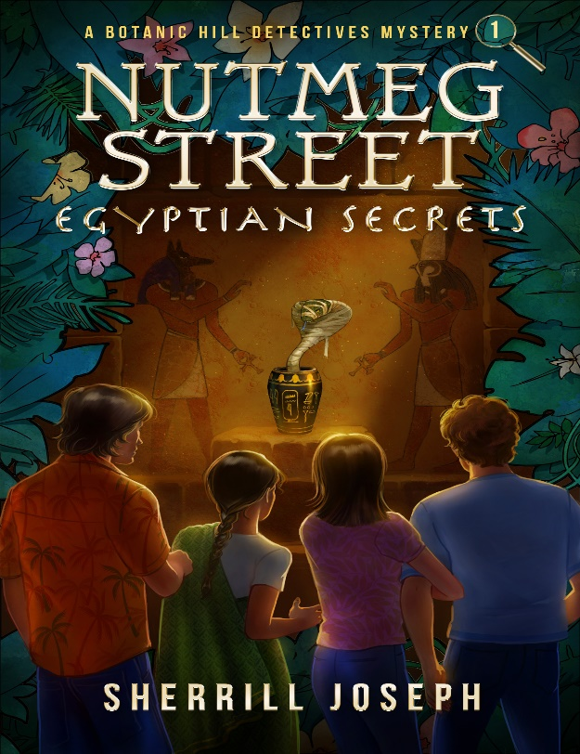

Enter the Book’s World: Preview the Text
Assemble the Book Club. Preview the text (activities below) before starting to read the book so as to introduce the text and build excitement and background knowledge. Once students have their books in hand, instruct them to:
- Look at the cover. Predict what the story will be about. Give supportive reasons.
- What genre is this text? How do you know? (mystery)
- Who is the author? Publisher? Publication year?
- To whom is the book dedicated? (Reactions?)
- Read the quote (epigraph). What could it mean? Who is Plato?
- Overview the Table of Contents. Which chapter grabs your attention the most? Why? Any questions forming? Predictions?
- Adult reads orally “The Beautiful Neighborhood of Botanic Hill.” Discuss deserts, botanicals, and what “danger often lurks in paradise” might mean.
- Study the Map of Botanic Hill in depth. Where does each detective live? What streets would the students want to live on? Why? Is Vine St. north or south of Ivy St? etc.
- Point out the Hawaiian Dictionary on pages 201-202.
- What work do we have to do to read a mystery book? (Type of characters we might meet; watch for what needs to be solved; overt and hidden clues and “red herrings”; how the author foreshadows them; how the author uses setting to create a mood; evaluate and weigh suspects, crimes, evidence, & motives; find essential details that could be cloaked as unimportant; connect information during “gaps”; hold suspicions at bay until all evidence is presented; put the puzzle pieces together logically to solve the mystery)

- Assign pgs. 17-56 for students to read on their own or with a reading buddy from the Book Club.

Nutmeg Street: Egyptian Secrets (continued) Part I: Chapters 1-4 and Front Matter

Dive Deeply into the Book: “Blooming” Discussion Questions to Enhance Comprehension
After student(s) have finished reading Chapters 1-4, assemble the Book Club to discuss the text, their thinking, and questions with this guide to assist. Remember: Sprinkle a variety of question types throughout every lesson. Keep pushing higher! Bloom’s Taxonomy is NOT grade specific. The six levels of questions are appropriate for ALL grades.

1.Remember (lowest level)  - Name the four detectives and describe them.  - List three things Mrs. T hires the detectives to do.  - What do the kids see out Mrs. T’s big front window?  - How does Lexi feel about Dr. Granger?  - Lanny dislikes snakes. True or false? (False: Moki) | 4.Analyze  - How are Moki and Lanny alike/different?  - Write a newspaper article to describe the case so far.  - What personality traits make these kids detectives?  - Tell five ways one of the detectives is like you.  - What clues/suspects are you holding on to now? Why?
2.Understand  - Summarize Chapters 1-4.  - Why do the detectives run out Mrs. T’s front door?  - Why does Rani wear a sari? Moki wear aloha shirts?  - In Chapters 2 and 3, Lexi is upset. Why? (2 reasons)  - Why do the detectives go talk to Dr. Abbott?  - Why are Dr. Granger and Ms. Ramsey talking?  - What problems occur when Dr. Kurtz leaves the boys? | 5.Evaluate  - Would you want the detectives as your friends? Why?  - Which chapter did you like best/least so far? Why?  - Was Dr. Kurtz right to run out of the room? Why?  - Is Dr. Abbott being fair or unfair toward Dr. T? Why?  - How would you deal with being locked in a room?  - What part of the story would you change? Why?
3.Apply  - If you were the 5th detective, what would your role be?  - Give some good advice to Moki and Lanny at the zoo.  - What questions would you ask Dr. A and Mrs. T?  - How would you begin to solve the Nutmeg Street case?  - How does this book remind you of others you’ve read? | 6.Create (highest level)  - Create an 8-frame comic strip showing events so far.  - Write a letter from Moki to Dr. Kurtz and her reply.  - Chart the world’s ten deadliest snakes. Cobras listed?  - Pretend you are Lanny applying to be a herpetologist.  - Research and report about synesthesia in other stories.

Vocabulary in Context—Possible Challenges (Focus words and book page numbers are bolded.)
Understanding words is essential to reading comprehension. Resist assigning the boring task of writing definitions from a dictionary, however. Instead, have kids use context clues (the sense of the other words in the sentence) to solve words. It’s much more rewarding and doesn’t kill reading enthusiasm. Discuss these if, when, and where needed.

- . . . with all its [Dr. T’s study] carefully copied treasure from Dr. T’s many Egyptian expeditions. (17)
- We benefit from our lineage, just like princes and princesses do when they become queens and kings. (18)
- . . . they [the detectives] inadvertently helped the French police catch two jewel thieves and a sizable hoard of . . . (19)
- The room’s lighting was subdued now, and the study was as still as a tomb. (22)
- . . . then [the detectives] sauntered back toward the [Mrs. T’s] house. (29)
- As my hero, the great fictional detective Sherlock Holmes, would say, “Give me facts, not just suppositions.” (32)
- . . . they [the detectives] would turn to the serious business of hashing over their case and formulating a plan of action (34)
- He [Uncle Rocky] accentuated the last word with a beat in the air from his large chopping knife. (35)
- . . . blue-violet eyes, “Liz Taylor eyes” as Uncle Rocky called them, referencing the beautiful, purple-eyed actress. (35)
- Hearing him wince in pain, she [Lexi] quickly released her grip. Grabbing flesh when exuberant was her bad habit. (36)
- . . . strong sunlight was now inundating his [Dr. Abbott’s] young guests. (45)
- Snakes aren’t your cup of tea, so to speak, Moki? (45)
- . . . given the Botanic Hill Detectives’ sterling reputation for apprehending thieves as you did in Paris. (47)
- That’s Ms. Augusta Ramsey, the owner of Ancient Sands Curio Shop . . . (49)
- . . . the boys sat with Dr. Tessa Kurtz, curator of herpetology. (50)
- All these snakes you see in their terraria are under special observation . . . (51)
- Egyptian cobra venom is very lethal, more powerful than a king cobra’s, but a bite from either snake can kill . . . (55)

Nutmeg Street: Egyptian Secrets (continued) Part I: Chapters 1-4 and Front Matter

Take the Book Farther into Your World
When you love a book, you don’t want to let it go. So, don’t! Have fun with these activities to cement your friendship.

Write (can be one well-written paragraph with details or several pages)  - A long sentence in Egyptian hieroglyphics.  - Your name in Egyptian hierolglyphics. | Cook  - Mrs. T’s giant chocolate chip cookies.  - Uncle Rocky’s enchilada dinner.  - Dr. Abbott’s big pot of Darjeeling tea (+ cookies)
Draw  - Mask Face’s pharaoh death mask as you picture it.  - Yourself outside your house on your favorite Botanic Hill street. Show the street you chose!  - Dr. Abbott’s office. | Research  - Synesthesia in the real world and in fiction.  - Plato, Greek philosopher.  - Ancient Egyptian history.
Make  - A detective’s kit, explaining your item choices.  - A papier-maché sphinx paperweight. | Read  - Nutmeg Street: Egyptian Secrets, Chapters 5-8, Pages 57-91. First, predict what you think will happen next. Then, dive in and see if you were correct! If yes, how so? If not, why not?
Listen/Watch  - (EDEN) Wildlife expert Nigel Marven as he travels to the world’s biggest hot-spots of deadly snakes and counts down each country’s top ten.  - (The Science Channel) “Egypt’s Unexplained Files.” | Create Your Own Category and Activities

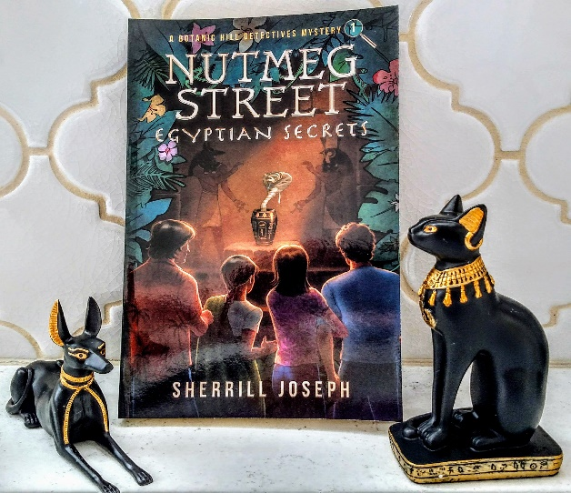
Nutmeg Street: Egyptian Secrets (continued) Part II: Chapters 5-8

Detailed Chapter Synopses for Adults: Pages 57-91 (Spoiler Alert!)

Chapter 5, “Hissing in the Dark” (pages 57-63): At 4:30, Lexi and Rani arrive at the twins’ house from the ARC to discover that the boys aren’t back yet from the zoo. They discuss dinner and Rani’s synesthesia with Uncle Rocky, then set the dining room table for “company night” dinner. All the detectives and their parents will attend. Meanwhile, Moki and Lanny have had no luck getting anyone to release them from the locked room. The boys pass the time joking around but smartly stay seated against the locked door so as not to upset any snake terraria. The reader learns that Moki’s mom died in a car accident in Hawaii. Moki shares his worry that Dr. Kurtz might have locked them in on purpose.

Chapter 6, “Dinnertime Excursion” (pages 64-72): The reader meets the twins’ pets: border collie Pharaoh and Abyssinian cat Cleo. Becky Marlton and Ian Wyatt (the twins’ parents) question the girls about the boys’ whereabouts and schedule. The boys are now very late getting home. Everyone, including Uncle Rocky, is worried. The dinner guests, Moki’s policeman dad Sgt. Dan, and Rani’s parents Devi and Gajara Kumar, arrive and are filled in on the situation. Dr. Wyatt calls the zoo without success. Sgt. Dan drives the twins’ parents to the zoo where the night watchman Mr. Willis takes the three of them to the cracked snake enclosure where Dr. Kurtz is working feverishly to repair it. Shocked to realize she might be responsible for locking the boys in the room, she leads the group in a run to the facility. Lanny and Moki are found safe and are freed. No terraria were disturbed. The group heads home to Quince Street and a late dinner.

Chapter 7, “Light Show” (pages 73-79): After dinner, the detectives are seated on the rug in their detective agency office in the twins’ attic. They discuss the day’s events, concerns, clues, and preliminary suspects. With them are Pharaoh and Cleo, plus Rani’s pet desert tortoise Tortuga. Uncle Rocky arrives with snacks. No sooner does he get seated to hear about the kids’ case when flashing lights flood the room. The detectives look out the attic’s little window to see Mask Face taunting them from the Quince Street Footbridge nearby! The four detectives plus Pharaoh clamber down three flights of stairs and past their startled parents in the living room in pursuit of Mask Face, who eludes them once again, disappearing into The Woods (see map). Sgt. Dan doesn’t let the kids go after him, but Pharaoh does and soon returns dragging Mask Face’s mask back across the footbridge. Moki finds a label inside that says “Ancient Sands Curio Shop.”

Chapter 8, “Cactusville Clues” (page 80-91): The twins’ tutor Bruce Wilding drives the four detectives in his classic blue 1967 Mustang convertible out to the desert to visit the Cactusville Reptile Gardens to study snakes. The reader learns that Bruce is twenty-five years old. The kids tease him about being their bodyguard, which he denies. They all discuss Mask Face and Augusta Ramsey, who is now implicated in the mystery by the label in the mask. Upon arrival, the kids revel in being “cool by association” with Bruce’s car when a visitor stops to admire it. The group enters the grounds and separates: Moki and Bruce go their own ways; and, Lanny, Lexi, and Rani go to the venomous snake show only to be disappointed that the cobras are off exhibit. The three confirm that the cobras are absent from their enclosures since they are being held at the zoo. At Lanny’s prompting, Rani shares a story about a close call with a cobra that she and her family had when they lived in India. Meanwhile, Bruce and Moki meet up. Moki is pushed into the Komodo dragons’ enclosure when someone purposely runs at him! Bruce jumps in and rescues him just in time. They meet the other three detectives for lunch, all sharing information. An after-lunch visit to the gift shop yields another surprise: Augusta Ramsey is there buying plaster cobra statues.

Nutmeg Street: Egyptian Secrets (continued) Part II: Chapters 5-8

Dive Deeply into the Book: “Blooming” Discussion Questions to Enhance Comprehension

After student(s) have finished reading Chapters 5-8, assemble the Book Club to discuss the text, their thinking, and questions with this guide to assist. Remember: Sprinkle a variety of question types throughout every lesson. Keep pushing higher! Bloom’s Taxonomy is NOT grade specific. The six levels of questions are appropriate for ALL grades.

1.Remember (lowest level)  - What kind of a snake is Wadjet?  - Who is Bruce Wilding?  - Who is spotted by Bruce and the detectives in the Cactusville gift shop?  - What story does Rani tell Lanny and Lexi about India?  - What are the twins’ pets names?  - Augusta Ramsey is on the footbridge. True or False? | 4.Analyze  - Why is the label in Mask Face’s mask important?  - Why does the blood drain from Dr. Kurtz’s face when she meets Lanny’s and Moki’s parents?  - How does Lanny know that Dr. Kurtz told the truth about the snakes coming to the zoo from Cactusville?  - What clues/suspects are you holding on to now? Why?
2.Understand  - Summarize Chapters 5-8.  - Why aren’t the boys back from the zoo on time?  - What do the parents do instead of eating dinner?  - What do the flashing lights in the attic mean?  - What happens to Moki at the Komodo dragon pen? | 5.Evaluate  - Were the boys’ parents too forgiving of Dr. Kurtz?  - Is Moki silly to be so afraid of snakes? Give reasons.  - Would you want to go to a venomous snake show?  - Should the detectives have continued chasing Mask Face across the footbridge? Why or why not?  - Defend Dr. Kurtz’s actions when the quake occurred.
3.Apply  - If you saw a wild animal coming toward you, what would you do?  - What would you say to Mask Face if you two met?  - Prepare a list of clues and suspects so far. | 6.Create (highest level)  - Draw a picture of the boys in the locked zoo room.  - Politely cure Lexi of squeezing people’s arms.  - Write a dialogue of what the kids might have said to Augusta Ramsey in the Cactusville gift shop.

Vocabulary in Context—Possible Challenges (Focus words and book page numbers are bolded.)
Understanding words is essential to reading comprehension. Resist assigning the boring task of writing definitions from a dictionary, however. Instead, have kids use context clues (the sense of the other words in the sentence) to solve words. It’s much more rewarding and doesn’t kill reading enthusiasm. Discuss these if, when, and where needed.

- You know, one of these days, instead of calling you [Moki] “bro,” maybe I’ll [Lanny] be calling you “bro-in-law.” (61)
- Rani had painted henna tattoos on Lexi’s arms after they finished their chores. (64)
- Pharaoh chomped with unrestrained gusto. Cleo nibbled with superb indifference. (65)
- . . . tempted by the soft chairs around the cooking island and the large platter of veggie hors d’oeuvres. (66-67)
- . . . they [parents] found Dr. Kurtz and a number of her assistants working feverishly to repair the snake enclosure. (69)
- . . . to observe anyone crossing over the Quince Street Footbridge, which spanned flower-strewn Lotus Canyon . . . (73)
- It’s just a feeling, Lexi added quickly, anticipating her brother’s chronic requests for evidence. (75)
- Ignorance can be bliss. (76)
- They [the detectives] clambered down three flights of stairs with the dog at their heels, barking wildly. (78)
- They [the detectives] had been outsmarted once again by the taunting masquerader, who quickly retreated . . . (79)
- The pungent aroma of desert sage mingled with every air molecule. (82)
- Moki, regaining his senses, realized his predicament and clambered over the side [of the reptile enclosure] . . . (88)

Nutmeg Street: Egyptian Secrets (continued) Part II: Chapters 5-8

Take the Book Farther into Your World
When you love a book, you don’t want to let it go. So, don’t! Have fun with these activities to cement your friendship.

Write (can be a well-written paragraph with details or several pages)  - A poem or story about venomous snakes. | Cook  - Uncle Rocky’s spaghetti dinner, revealing the “secret ingredient.” Don’t forget the brownies!
Draw  - A picture of Uncle Rocky left behind in the detective agency office with Tortuga on his lap.  - Sketch Mask Face in The Woods. | Research  - How sick animals are cared for at zoos.  - Reptile Gardens in the USA.
Make  - The menu for next Saturday’s “company night” dinner at the twins’s house. | Read  - Nutmeg Street: Egyptian Secrets, Chapters 9-12, Pages 92-127. First, predict what you think will happen next. Then, dive in and see if you were correct! If yes, how so? If not, why not?
Listen/Watch  - The San Diego Zoo’s “Animal Live Cams” at zoo.sandiegozoo.org. You can watch polar bears, apes, penguins, pandas, koalas, baboons, and hippos in real time! | Create Your Own Category and Activities

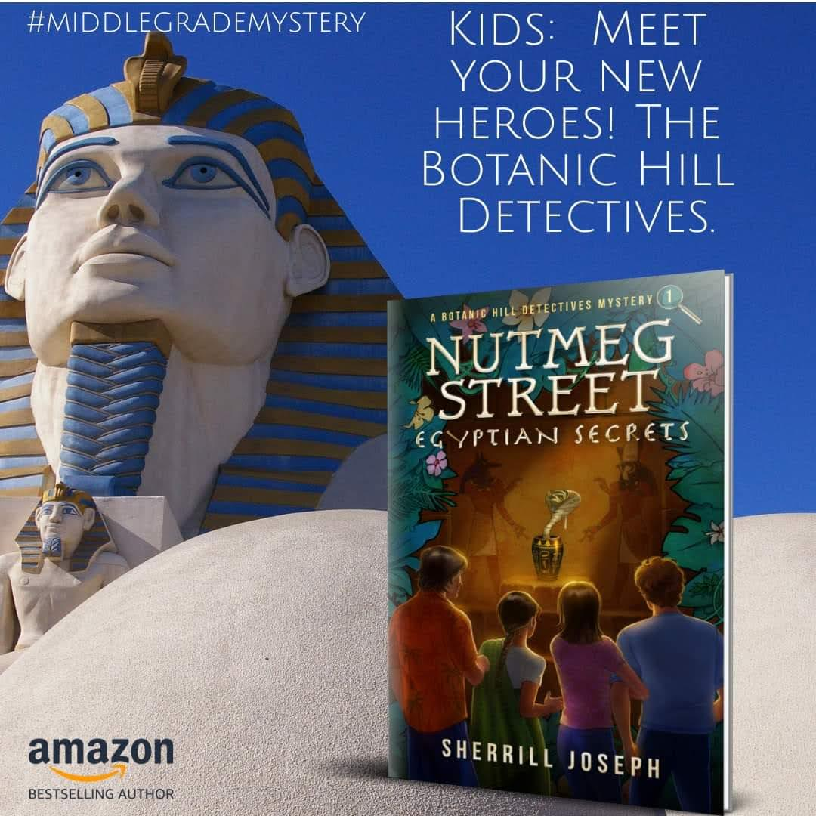
Nutmeg Street: Egyptian Secrets (continued) Part III: Chapters 9-12

Detailed Chapter Synopses for Adults: Pages 92-127 (Spoiler Alert!)

Chapter 9, “The Egyptian Pond” (pages 92-99): The next morning, the four detectives and Tortuga are in Mrs. T’s side yard admiring Dr. T’s beloved Egyptian Pond, described in detail and preparing to tell Mrs. T about their meeting with Dr. Abbott. Mrs. T reports that she has found numerous cracks in and around the pond’s statues and sphinx following the earthquakes and has called Mr. Sam Bailey, the mason from Seeds Sow Fine Gardeners, who built the statues. Soon, he arrives and is introduces to the kids. He remarks that he’s seen them on the Internet. He confirms via his inspection that there is damage to the statues and schedules his earliest time the following week to do the repairs. Tortuga approaches him, causing him to jump up quickly onto the pond stage since he’s not fond of reptiles. After he leaves, the detectives tell a pleased Mrs. T that Dr. A believes Dr. T was innocent of the theft. Moki discovers a slip of paper in Tortuga’s mouth that turns out to be a sales receipt for yesterday from Shady’s Lunch Shack out in Desert County, north of Cactusville. They all conclude that Mr. Bailey must have dropped it. Using their cell phones, the detectives determine that there is a pit of “modern” natron in Desert County. As they leave Mrs. T’s, Lexi and Rani conclude that based on something Rani’s geologist dad said about the earthquakes, the Egyptian Pond statues must have been poorly built.
Chapter 10, “Curious Curios” (pages 100-105): The kids arrive at Ancient Sands Curio Shop on Jacaranda Street. There are no other customers. Lexi shares that earlier that morning, Uncle Rocky told her that he saw Augusta Ramsey yesterday at Ground for a Cup Coffee House. She met with a man the kids determine to be Dr. Granger. Lanny wants evidence that the two are up to no good. The kids spread out in the shop to look for more masks like Mask Face’s. They find the plaster cobras Ms. R bought in Cactusville yesterday. Moki amazes everyone by finding more Mask Face masks! Ms. R comes out from the back office and doesn’t seem happy about her four customers. She avoids Lanny’s questions about being with Dr. G at the ARC and returns to her office. Moki and Rani look at the masks while Lexi and Lanny check out some hieroglyphics books. A scraping sound is heard and before they can get out of the way, a giant plaster cobra statue topples over toward the twins!
Chapter 11, “Alley Spy” (pages 106-117): Moki and Rani save the twins by pushing them out danger’s way. Ms. R emerges and looks astounded at what happened. Lanny uncharacteristically gets angry at her because of the accident. She orders them out of the shop. He almost trips her up when he asks who purchase one of the masks recently. Once outside, they agree that she has implicated herself in their case. They see a man staring at them from the alley up ahead behind Ms. R’s shop. They start chasing him, but he gets away easily. Moki names him Alley Spy. Because of his speed and Rani’s synesthesia (mac ‘n’ cheese taste), Lexi concludes that he and Mask Face must be the same person. Lanny is skeptical. Rani conjectures that Alley Spy and Ms. R together pushed the cobra statue over onto the twins. Soon, the kids are back at the twins’ house. Uncle Rocky gives them lunch, listens to the happenings of the day with concern, and shares that he has seen Ms. R with yet another person that morning in front of her shop. Moki names the person Package Man since Ms. R gave the man two packages. The kids do much theorizing about this latest Person of Interest and his place in the scheme of things. The kids head out the back door, through the yard and gate, and enter Moki’s backyard. The reader meets Moki’s brainy pet mynah bird Aloha. The boys play Chop-Chop-Composters, whacking rotten fruit with a katana (sword). The girls get disgusted and leave to have a tea party and brownies at Lexi’s.
Chapter 12, “Midnight Pond Prowler” (pages 118-127): Rani and Moki arrive in the twin’s upstairs classroom just as Bruce finishes a lesson on ancient Egyptian mummification. Lexi enjoys teasing Rani a bit with some gross lesson items. As they’re discussing Canopic jars, a phone call from Mrs. T interrupts them. She reports a moving light and tapping sounds by the Egyptian pond last night. The kids go to her house to find the police, including Sgt. Dan, investigating. The pond statues’ cracks are larger but especially those on the sphinx. The kids and Sgt. Dan do some theorizing. A business card belonging to Buster Hobart is found by the pond and taken as evidence. The kids decide to secretly go see Mr. Hobart ahead of the police. Rani suggests they return that night to have a slumber party on Nutmeg Street to protect Mrs. T and to watch for the prowler’s return.
Nutmeg Street: Egyptian Secrets (continued) Part III: Chapters 9-12

Dive Deeply into the Book: “Blooming” Discussion Questions to Enhance Comprehension
After student(s) have finished reading Chapters 9-12, assemble the Book Club to discuss the text, their thinking, and questions with this guide to assist. Remember: Sprinkle a variety of question types throughout every lesson. Keep pushing higher! Bloom’s Taxonomy is NOT grade specific. The six levels of questions are appropriate for ALL grades.

1.Remember (lowest level)  - Who built the Egyptian pond and its statues?  - Whom did Uncle Rocky see in the coffee shop?  - What big evidence does Moki find in the curio shop?  - What happens right after the kids leave the curio shop?  - What does Mrs. T hear and see in the night?  - What is Rani’s “fabulous idea” to help Mrs. T? | 4.Analyze  - Explain fully what Lanny means when he says Ms. Ramsey has implicated herself in their case.  - What do the police and detectives conclude about the statue cracks? Why?  - What is the significance of the business card found by the pond?  - Connects the mason’s lunch receipt to natron.
2.Understand  - Summarize Chapters 9-12.  - What does Mrs. T find when she inspects the pond?  - How do the kids know that Mask Face has dark hair?  - What is “a plant” in detective/police talk?  - What does Moki say accounts for the larger cracks on the pond statues?  - What danger awaits the detectives in the curio shop? | 5.Evaluate  - Would you want an Egyptian Pond? Why or why not?  - Do you believe that Ms. Ramsey and Alley Spy are working together? Why or why not?  - How does Mr. Bailey feel about the detectives? Why?  - Which detective is doing the best job so far? Why?  - Would you like to have a tutor like Bruce? Why?
3.Apply  - Share a time when you had a near accident.  - Prepare a list of clues and suspects so far.  - What questions would you ask Ms. Ramsey?  - Demonstrate the connections among all the Persons of Interest. | 6.Create (highest level)  - Draw a picture of the boys in the locked zoo room.  - Politely cure Lexi of squeezing people’s arms.  - Write a dialogue of what the kids might have said to Augusta Ramsey in the Cactusville gift shop.

Vocabulary in Context—Possible Challenges (Focus words and book page numbers are bolded.)
Understanding words is essential to reading comprehension. Resist assigning the boring task of writing definitions from a dictionary, however. Instead, have kids use context clues (the sense of the other words in the sentence) to solve words. It’s much more rewarding and doesn’t kill reading enthusiasm. Discuss these if, when, and where needed.

- . . . [the Egyptian Pond] was a haven for dozens of sparkling goldfish and colorful lotuses. (92)
- They were mesmerized by the pond’s raised stage. (92)
- It [the Egyptian pond stage] evokes an ancient temple by the Nile with its palm trees in large pots, . . . (92)
- . . . we’ll [Sam Bailey and the garden shop] make everything right as rain if need be. (95)
- He [Moki] always preferred being the chauffeur of the tortoise taxi. (99)
- A dusky stillness and natural light enveloped [the curio shop interior] . . . (100)
- . . . [Moki] dexterously avoided upsetting a display . . . (100)
- . . . statues of numerous ancient Egyptian deities scattered around the shop. (102-103)
- . . . the bird-like proprietress, Augusta Ramsey, emerged from behind an ornate purple and gold curtain . . . (103)
- Lanny couldn’t help but hear a tinge of smugness in [Ms. Ramsey’s] voice. (104)
- I’d say Ms. Ramsey just implicated herself in our case . . . (108)
- We need to rethink who the man is—in addition to being her accomplice. (109)
- Ta-ta, Philistines. . . . Yeah, ta-ta Barbarians . . . (117)
- . . . a sultry wind gusted steadily through the mullioned windows in the twins’ third-floor classroom . . . (118)
- Bruce emphasized his admonishment with firmly planted hands on hips. (123)

Nutmeg Street: Egyptian Secrets (continued) Part III: Chapters 9-12

Take the Book Farther into Your World
When you love a book, you don’t want to let it go. So, don’t! Have fun with these activities to cement your friendship.

Write (can be a well-written paragraph with details or several pages)  - A story about an ancient Egyptian mummy. | Cook  - Uncle Rocky’s lunch.  - Lexi and Rani’s tea party.  - Brunch to eat by the Egyptian Pond.
Draw  - A picture of Uncle Rocky left behind in the detective agency office with Tortuga on his lap.  - Sketch Mask Face in The Woods.  - The Egyptian Pond. | Research  - Ancient Egyptian gods and goddesses (deities).  - The kingdoms of ancient Egypt.  - The Great Pyramid of Giza/Khufu.
Make  - A mummy.  - The four Canopic jars and contents.  - A diorama of the Egyptian Pond and its stage. | Read  - Nutmeg Street: Egyptian Secrets, Chapters 13-16, Pages 128-161. First, predict what you think will happen next. Then, dive in and see if you were correct! If yes, how so? If not, why not?
Listen/Watch  - (YouTube TV) “Ancient Egypt 101: National Geographic” (6:14). | Create Your Own Category and Activities
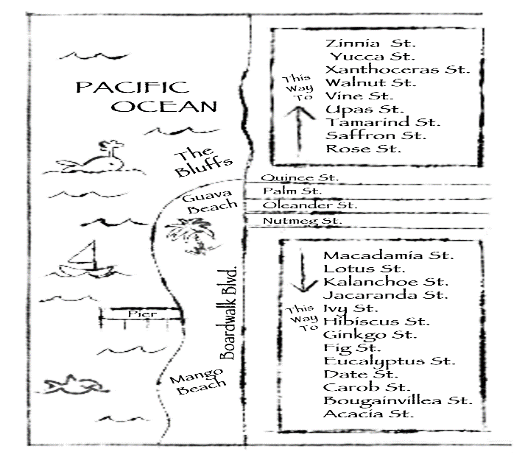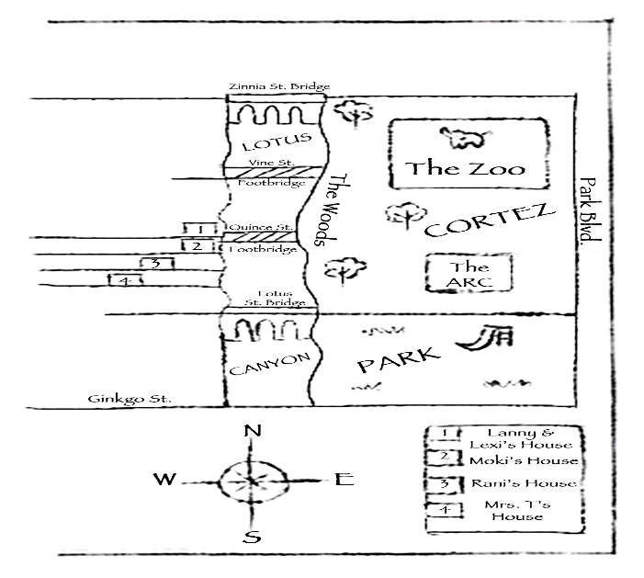

Nutmeg Street: Egyptian Secrets (continued) Part IV: Chapters 13-16
Detailed Chapter Synopses for Adults: Pages 128-161 (Spoiler Alert!)

Chapter 13, “Pond Watch” (pages 128-137): Bruce drives the detectives to Hobart’s Pond Pad to keep an eye on them. There is some dialogue about Bruce’s “cool” car and riding shotgun. He questions the need to spend the night at Mrs. T’s and cautions them against taking any unnecessary chances. Bruce doubts that helpful Buster Hobart will be a suspect since he knows Hobart from college. Once inside the shop, Bruce introduces Buster to the kids. Buster shares that chemistry is important in his job of designing and stocking ponds so the water is habitable and discusses what could make it toxic. He knows Dr. Kurtz and has worked with her on toxins. When told about the business card found at the Egyptian Pond, Hobart answers questions, gives an alibi for last night, and says he doesn’t use that kind of card now. He mentions knowing Sam Bailey since the two built the pond together last summer and shares that the mason came from the Midwest. He remembers that Bailey was very shy and quiet at the Thornsleys’ and that Hobart had to do most of the talking. Back in the car, they mostly discount Hobart as a suspect. Lanny thinks they should go see Baily, but Bruce overrules it since the kids need to get some rest before their slumber party. Lanny is debating about how to ask his parents’ permission to go to the slumber party without setting off any alarm bells. Later, at Mrs. T’s, they set their ambush plan into effect, taking shifts to watch in the garden. Moki and Lexi begin; Rani and Lanny are the last. The only prowler is an opossum family.
Chapter 14, “Red, White, and a Blue Sedan” (pages 138-145): The sleepy twins come downstairs at noon to find Uncle Rocky working in the kitchen and a rainstorm threatening later in the evening. Rani and Moki arrive. They all tell the cook about the “opossum stroll” on Nutmeg Street, evading any questions about taking risks. To change the subject, Lanny proposes they go to Mango Beach instead of seeing Sam Bailey. Everyone agrees, and Rocky makes them a picnic lunch to take. Bruce comes home and drives everyone to the beach. They admire the patriotic decorations on Board Walk Boulevard, ready for the Fourth of July. They spread out their beach gear, and Bruce watches the four surf. During lunch, the kids talk about current suspects: Ramsey, Granger, Mask Face, and maybe Bailey, whom they agree to see tomorrow since they’re still wondering about his shyness. Suddenly, the rainstorm arrives early. Everyone grabs beach gear, and the kids get to the car ahead of Bruce. Lexi sees a speeding car coming at them and knocks everyone out of the way just in time. They conclude it was Mask Face since it’s the same blue car. Bruce arrives having witnessed the near accident. All pile into the car to follow, but Mask Face eludes them once again. After getting ice cream, they go home to rain and sleep.
Chapter 15, “Disaster and Discovery” (pages 146-154): Bruce is giving the twins a lesson on Egyptian hieroglyphics when they are interrupted by another phone call from Mrs. T. Lexi takes the call and listens to the distraught woman. Lexi explains to Lanny, Bruce, and Uncle Rocky that the Egyptian Pond has been destroyed during the night! The statues are more hacked up, and all the pond life is dead. Bruce drives the twins to Mrs. T’s where they meet Rani and Moki. Mrs. T thinks the trespasser took advantage of last night’s storm’s noises. Rani and Lexi burst into tears at the sight. Upon further inspection, the sphinx’s paws have deeper grooves in them that appear to have been deliberately made—by a person, not the storm or the earthquake. The police and Buster Hobart are called to assist. The reader meets Sgt. Dan’s partner, Sgt. Yolanda Osuna, who says it’s her opinion that the damage was done mainly by a person, not nature. Hobart arrives and is shocked by the sight of the pond he helped build. He takes water, fish, and plant samples to analyze, saying he’ll call in Dr. Kurtz to assist. Sgt. Dan wants both of them to send him their reports. Meanwhile, Lanny and Rani get excited about a hairline crack by the sphinx’s shoulder. They chip away the plaster and find the stolen Egyptian burial urn!
Chapter 16, “Tomb Treasure” (pages 155-161): Even though Mrs. T knows it looks incriminating for her husband once the urn is found, she still believes him innocent. Lanny and the police know that proof of his innocence is needed. Sgt. Dan calls the ARC to come remove the urn and determine its authenticity. While they wait for Dr. Abbott and the others to arrive, the kids theorize about how the urn could have gotten inside the sphinx that resulted in Dr. T being victimized. Soon, the excited Drs. Abbott, Wyatt, Marlton, and Granger arrive. After each inspects the urn, it is declared authentic! Then, it’s boxed for transport to police headquarters.
Nutmeg Street: Egyptian Secrets (continued) Part IV: Chapters 13-16
Dive Deeply into the Book: “Blooming” Discussion Questions to Enhance Comprehension
After student(s) have finished reading Chapters 13-16, assemble the Book Club to discuss the text, their thinking, and questions with this guide to assist. Remember: Sprinkle a variety of question types throughout every lesson. Keep pushing higher! Bloom’s Taxonomy is NOT grade specific. The six levels of questions are appropriate for ALL grades.

1.Remember (lowest level)  - What kind of a car does Bruce drive?  - What did Lexi buy at Hobart’s shop?  - Name the beach the detectives go to before the storm.  - Who almost hit the kids with a blue car at the beach?  - What happens to the Egyptian Pond?  - What is the name of Sgt. Dan’s partner?  - What do the detectives find inside the sphinx? | 4.Analyze  - Why do the kids debate about who rides shotgun?  - What does Bruce ask the kids about the sleepover at Mrs. T? Why does he say “unnecessary chances?  - How do the kids conclude that Hobart is innocent?  - What were your thoughts about the parking lot event?  - Analyze why strange things keep happening around Mrs. T’s house since her husband died.  - Give reasons why the detectives cross Buster Hobart off their list of suspects after the pond is destroyed.  - Why do you think the statues and pond life were destroyed?  - Why would catching the urn’s thief be catching the blackmailer?
2.Understand  - Summarize Chapters 13-16.  - Why do the kids and Bruce go to Hobart’s Pond Pad?  - What does Hobart say about the business card?  - What are “cool points”?  - Explain the outcome of the slumber party at Mrs. T’s.  - Why did Lexi knock her friends down in the beach parking lot?  - Why is Mrs. T crying on the phone?  - What is Lanny’s theory about the pond prowler?  - How did the urn end up where it was found? | 5.Evaluate  - Should the adults give the detectives more freedom to solve the case on their own? Why or why not?  - Do you prefer to ride shotgun in a car? Why/why not?  - Consider if Lanny is risking his trustworthy reputation with his parents and Bruce about the slumber party.  - Defend Dr. T, who is accused of stealing the urn.  - Critique the detectives’ theories on pages 157-159.  - Weigh the likelihood of guilt for each of your suspects.  - If you could assign a shape to each detective, what would each be and why?
3.Apply  - When have you been careful about the way you asked your parents for permission? What was the outcome?  - Would you want to be an Egyptologist? Why/why not?  - Tell about a time when you were someone’s hero.  - Draw a picture of something of yours that was lost or destroyed. How did you feel? How do you feel now? | 6.Create (highest level)  - A clay or papier-maché replica of the Egyptian burial urn.  - A chart of the detectives’ theories from Chapter 16 and your beliefs or ideas about each.
Vocabulary in Context—Possible Challenges (Focus words and book page numbers are bolded.)
Understanding words is essential to reading comprehension. Resist assigning the boring task of writing definitions from a dictionary, however. Instead, have kids use context clues (the sense of the other words in the sentence) to solve words. It’s much more rewarding and doesn’t kill reading enthusiasm. Discuss these if, when, and where needed.

- . . . Bruce asked . . . what the police found at Mrs. T’s that necessitated the four kids spending the night there . . . (129)
- It ensures their ponds are habitable for particular aquatic fish and plants. (130)
- Their mason Sam Bailey and I collaborated on the building of the pond about a year ago. (131)
- He [Hobart] doesn’t seem like the type to jeopardize a job he enjoys . . . . Plus, he had an alibi for last night. (132)
- She [Lexi] imagined herself an Egyptologist . . . planning the work for the next arduous day ahead. (136)
- Pharaoh and Cleo were chasing each other’s tails, clattering indiscriminately around the first floor rooms. (146)
- He [the pond prowler] must have taken advantage of the storm’s noise. I slept right through his shenanigans. (148)
- I smell a frame-up, Lexi said quickly, and not a very cleverly disguised one at that. (150)
- Sgt. Osuna . . . and Lanny were discussing whether it was feasible that the rainstorm alone could have done . . . (150)
- Heavens to Betsy! Mrs. T almost passed out as Bruce settled her into a patio chair. (155)
- . . . the treasure gleamed brilliantly in the afternoon sun, seemingly basking in its freedom to enjoy daylight again. (161)
Nutmeg Street: Egyptian Secrets (continued) Part IV: Chapters 13-16

Take the Book Farther into Your World
When you love a book, you don’t want to let it go. So, don’t! Have fun with these activities to cement your friendship.

Write (can be a well-written paragraph with details or several pages)  - A story entitled “It Came from the Pond!”  - A poem about a sphinx’s secrets.  - A movie script for your favorite chapter so far. | Cook  - A picnic lunch for the beach.  - Mrs. T’s chocolate cake.
Draw  - Sketch the detectives staking out Mrs. T’s yard as they watch for the pond prowler.  - The Egyptian burial urn with all its detail. | Research  - Aquatic plants.  - The treasures found in Tutankhamun’s tomb.  - How science was used in ancient Egypt.
Make  - A beach bag with room for your detective gear.  - A mini Egyptian pond in your yard.  - A “Wanted” poster of the thief, in your opinion. | Read  - Nutmeg Street: Egyptian Secrets, Chapters 17-20, Pages 162-205 to finish the book. First, predict what you think will happen next. Then, dive in and see if you were correct! If yes, how so? If not, why not?
Listen/Watch  - (The Science Channel) “Mysteries of Egypt” (many episodes over seasons).  - Nutmeg Street: Egyptian Secrets on audiobook:  If new to audible—adbl.co/3ebgXSF  If already a member—adbl.co/2TuUR5G | Create Your Own Category and Activities

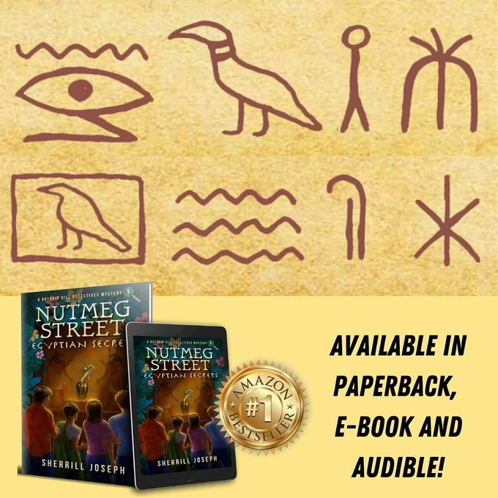
Nutmeg Street: Egyptian Secrets (continued) Part V: Chapters 17-20 and Back Matter

Detailed Chapter Synopses for Adults: Pages 162-199 (Major Spoiler Alert!)

Chapter 17, “A Clue from Ancient Egypt” (pages 162-172): At the breakfast table the morning after the burial urn was found, Lexi is distracted. She thinks that spirits from ancient Egypt followed her home from Mrs. T’s and are now telling her that the sphinx at the Egyptian Pond has more to tell. She convinces Lanny that all four detectives should return to Mrs. T’s to investigate the pond sphinx more before going to see Mr. Bailey. As Uncle Rocky serves a celebration breakfast, the twins are joined at the table by their parents, who said they felt like rock stars yesterday when news spread around the ARC that the kids had found the urn. Lexi wonders if what was inside the urn was damaged, like crystallized cobra venom. Lanny casually wonders if anything from the urn could have ended up in the pond. Lexi thinks he’s brilliant because it’s given her an idea. The detectives go to Mrs. T’s to check for venom drainage, but Lexi finds the hieroglyphs of Menes and Wadjet on the back of the sphinx’s head instead. She leads the group at a run to the study, declaring that they are about to solve the rest of the mystery. From Dr. T’s book about Menes and Wadjet, she finds a letter from Dr. T to Mrs. T, dated a few weeks before he died in April. When Mrs. T reads it aloud, they learn that the blackmailer and real urn thief was Dr. T’s scheming, younger half-brother Sebastian Thornsley, who was jealous of Dr. T’s success and fame. Dr. T kept it all a secret to protect his wife. Lanny is happy that the letter is evidence that exonerates Dr. T of the theft. A photo is enclosed with the letter. Looking at it, Lexi announces that she knows who Sebastian Thornsley is!
Chapter 18, “Help from Modern Science” (pages 173-184): Lexi says that Sebastian Thornsley is the mason Sam Bailey! She explains how he must have disguised himself around Dr. T during the pond’s construction. Rani and Moki start piecing together more of the puzzle, connecting Sam Bailey to Mask Face and other Persons of Interest. The group calls Dr. Abbott and others to share the great news and head to the ARC with the evidence to exonerate Dr. T. A huge group congregates in Dr. A’s office, including Hobart and Kurtz with their reports about the pond toxins. Lexi reads Dr. T’s letter aloud. Sgt. Dan confirms that Sam and Sebastian are the same person by calling the Midwest prison where Sebastian was released just last summer and that his prison name was “Snitch.” The detectives theorize how Sam/Sebastian/Snitch gained access to the ARC last October and stole the urn, who his girlfriend is, and how he’s possibly connected to their Persons of Interest. They connect the dots for those in the meeting about how Snitch used the pond to hatch his plan against Dr. T and lead them to the urn. Buster Hobart and Dr. Kurtz each give their toxicology reports, basically showing the mistakes made by Sam Bailey, e.g., the cobra venom found in the pond was from a king cobra, not an Egyptian cobra. Sgt. Dan reminds the kids that conclusive evidence must be found to link Sam to Augusta Ramsey. Dr. Abbott says he will exonerate Dr. T locally and worldwide. Moki proposes setting a trap that night for Sam.
Chapter 19, “Snitch” (pages 185-192): Moki explains that since nothing about the urn’s recovery has been in the news, Sam and his accomplice might come out of hiding to find out why. He proposes the detectives stake out the pond that night. The adults will only allow it if Sgt. Dan and Bruce are also there. The detectives agree but are silently disgruntled by this parental intrusion. That night at Mrs. T’s, Moki, Lexi, and Sgt. Dan form one team; Lanny, Rani, and Bruce form the second. They all conceal themselves near the pond. Two hours later, they see a dark form sneaking across the yard and noiselessly leap onto the pond stage to inspect the sphinx. The ambushers jump out and capture Sam Bailey! Moments later, Sgt. Osuna enters the yard holding Augusta Ramsey, who couldn’t resist joining Sam, her boyfriends. Their contempt for one another grows as Sgt. Dan reveals how Sam used her and the mistakes they made via the Hobart and Kurtz reports. Sam and Augusta are taken to jail. Mrs. T slept through it all. The kids go to Rani’s for mac ‘n’ cheese.
Chapter 20, “Festival and Celebrations” (pages 193-199): Everyone is celebrating Dr. T’s exoneration at the Las Palmitas Paradise Days Festival in late August. Loose ends are tied up in an explanation about Sam and Augusta’s trial. Sam admits to being all the detectives’ Persons of Interest. The pair are sentenced to long prison terms. On September 1, everyone assembles in Mrs. T’s garden by the newly restored Egyptian Pond to celebrate what would have been Dr. T’s 75th birthday. Gifts are presented, including a new sphinx for the pond and mini golden sphinx figurines for the kids. The detectives lament the end of their case until they hear that Aunt Connie is coming next week. More adventures await!
Nutmeg Street: Egyptian Secrets (continued) Part V: Chapters 17-20 and Back Matter

Dive Deeply into the Book: “Blooming” Discussion Questions to Enhance Comprehension
After student(s) have finished reading Chapters 17-20 and the Back Matter through page 205, assemble the Book Club to discuss the text, their thinking, and questions with this guide to assist. Remember: Sprinkle a variety of question types throughout every lesson. Keep pushing higher! Bloom’s Taxonomy is NOT grade specific. The six levels of questions are appropriate for ALL grades.

1.Remember (lowest level)  - What special breakfast does Uncle Rocky serve?  - Where is the burial urn now?  - What does the burial urn look like?  - What is found inside Dr. T’s book?  - What are the clues Dr. T left for Lexi?  - What does the letter Lexi found state?  - Who stole the urn and blackmailed Dr. T?  - Why do the detectives and Mrs. T visit Dr. Abbott?  - Was Dr. T exonerated from the urn’s theft?  - Who is Sam Bailey’s girlfriend?  - What did Sam do to the sphinx’s paws?  - How is Sam’s accomplice caught? Who is it?  - How does his accomplice feel about Sam now?  - What happened to the ransom money Dr. T paid?  - What gifts are presented at Dr. T’s birthday party?  - What is Sherrill Joseph’s dog’s name? | 4.Analyze  - Why is Lexi distracted at the breakfast table?  - What is the significance of the paperweight sphinx and the pond sphinx matching according to Lexi (pg. 163)?  - Why does Lexi get excited when Lanny wonders if any cobra venom could have ended up in the pond?  - Chart the chain of events Lexi uses beginning with the clues from the pond sphinx to solve who stole the urn.  - How are the photos and the word “agile” great clues?  - Why does Mrs. T’s hand fall “limply away from the photo’s edge” (pg. 173)?  - Why does Snitch poison the Egyptian Pond?  - How is Augusta Ramsey implicated in the theft?  - Why does Dr. M call Moki’s ambush plan “brilliant”?  - What does it mean when “Lanny caught the tutor’s eye & silently thanked him for not ratting on them”? (186)  - How does Sam figure out that he’s been trapped?  - Why does Rani offer to make the kids mac ‘n’ cheese?
2.Understand  - Summarize Chapters 17-20.  - What does “a twin thing” mean on page 163?  - What caused the twin’s parents to feel like rock stars?  - What damage is there to the urn?  - Explain what Lexi finds when she checks the sphinx.  - What secret did Dr. T keep from Mrs. T?  - How did Sam Bailey disguise himself around Dr. T?  - What other names has Sam Bailey used?  - How did Sam gain access to the ARC last October?  - How did Sam use the urn to make Dr. T look guilty?  - What does Moki propose they do to catch Sam?  - What happens as a result of the pond stake-out?  - What two events seemed “beyond good luck” to Sam?  - Why did Sam wear disguises?  - What else is revealed about Sam’s crime in Ch. 20?  - What did you learn from the Hawaiian Dictionary? | 5.Evaluate  - Would you want to be a twin? Discuss.  - Judge whether or not Dr. T did the right thing keeping his secret from Mrs. T while he was living.  - Critique all the detectives’ theories in Chapter 18.  - Evaluate Snitch’s plan to implicate Dr. T in the theft.  - Should the adults give the detectives more freedom to solve the case on their own? Discuss this repeated Q.  - Is Moki’s ambush plan to catch Sam “brilliant”? Why?  - Summarize the “loose ends” brought out in the trial.  - Support this statement: I want to be a detective like __?  - Chart the book’s clues and where they led you. Were any clues “red herrings”? How do you know?  - Did Sam being the criminal surprise you? Explain.  - Which part of the text could be improved?  - Did you like the ending of the story? Why/why not?  - Did the author write a good mystery? Why/why not?  - Which detective was your favorite? Why?  - Was the book’s title a good title or a poor one? Why?
3.Apply  - Have you ever kept an important secret? Why? What was the outcome? Should you have told earlier?  - Tell about a time you helped someone. Illustrate it.  - What questions would you ask Snitch and Ramsey?  - What questions would you ask our four detectives?  - How can you discover a talent you have? | 6.Create (highest level)  - Pretend you are Sam Bailey and Augusta Ramsey’s lawyer. How would you defend them in court?  - Rewrite the ending of the book.  - Write a letter to Mrs. T about her ordeal and its end.  - Illustrate some new Hawaiian words you’ve learned.  - You are a librarian. Recommend this book to a reader.
Nutmeg Street: Egyptian Secrets (continued) Part V: Chapters 17-20 and Back Matter
Vocabulary in Context—Possible Challenges (Focus words and book page numbers are bolded.)
Understanding words is essential to reading comprehension. Resist assigning the boring task of writing definitions from a dictionary, however. Instead, have kids use context clues (the sense of the other words in the sentence) to solve words. It’s much more rewarding and doesn’t kill reading enthusiasm. Discuss these if, when, and where needed.

- Only now, it [the twin thing] is with an idea, though a wonky one. (163)
- Emblazoned on the book’s cover were the two hieroglyphs identical with those on the stone sphinx. (167)
- He [Dr. T] must have figured that, eventually, I [Lexi] would find his clue and decipher it! (168)
- He (Sebastian T] further stipulated that I [Dr. T] must keep his identity and guilt a secret and take the blame myself. (169)
- . . . tears of sorrow for all Dr. and Mrs. T had endured at the hands of the scheming, sadistic Sebastian Thornsley. (171)
- . . . she [Lexi] picked up the letter and enclosures from the rug and judiciously began examining the small man . . . (172)
- Each guest was ushered into Dr. Abbott’s office. (176)
- It [Bailey] was the maiden name of my late husband’s paternal grandmother . . . (178)
- I [Buster Hobart] found high concentrations of sodium chlorate, a nonselective herbicide available at some . . . (180)
- Moki cracked a cagey smile. (184)
- The four kids were mildly disgruntled, however, that two adults would be participating in what they had hoped . . . (187)
- I [Augusta Ramsey] thought I might end up with this pair of silver bracelets, but I did it because I cared about you. (190)
- The criminals’ contempt for one another’s botching of the plan grew along with their kicking and shouting. (191)
- . . . he [Dr. Abbott] posthumously presented the Egyptologist with the ARC’s Most Honored Scientist Award . . . (193)
- . . . the evidence presented against them [Sam and Augusta] corroborated all the Botanic Hill Detectives’ theories. (193)
- . . . wearing disguises to pull off his sinister caper and to attempt to harm or intimidate the kids away from his trail. (193)
- The black onyx eyes (of the mini golden sphinxes] shone enigmatically. (197)

Take the Book Farther into Your World
When you love a book, you don’t want to let it go. So, don’t! Have fun with these activities to cement your friendship.

Write (can be a well-written paragraph with details or several pages)  - A letter or review to the author with questions and comments about her life and the book. You can send it to her at sherrilljoseph.com/contact. | Cook  - Uncle Rocky’s celebration breakfast.  - Rani’s Mac ‘n’ Cheese.  - Uncle Rocky’s chocolate sheet cake.  - Party food.
Draw  - A picture of Dr. T’s birthday celebration.  - A sketch inside the court room during the trial.  - A scene from your favorite chapter. | Research  - The Hawaiian language, culture, and customs.  - The basics of a US criminal court case.
Make  - A party to celebrate the happy ending of the case.  - A book jacket for the story that illustrates the kind of book it is and what the story is about.  - A gift or card for someone who helped you. | Read  - Eucalyptus Street: Green Curse, Chapters 1-5, Pages _____. First, predict what you think will happen. Then, dive in and see if you were correct! If yes, how so? If not, why not? Out in Oct. 2020.
Listen/Watch  - Observe a real courtroom session and learn about the American judicial process. Teachers should contact their local US District Clerk’s Office to set up a visit. Allow several weeks of lead time to arrange a date. | Create Your Own Category and Activities
Teacher’s Notes

